### 

### Semester One Examination, 2020

### Question/Answer booklet

# MATHEMATICS METHODS

**UNIT 3**

## Section Two:

## Calculator-assumed

| **Your Name:** |  |
| --- | --- |
| **Your Teacher’s Name:** |  |

## Time allowed for this section

Reading time before commencing work: ten minutes

Working time: one hundred minutes

## Materials required/recommended for this section

***To be provided by the supervisor***

This Question/Answer booklet

Formula sheet (retained from Section One)

***To be provided by the candidate***

Standard items: pens (blue/black preferred), pencils (including coloured), sharpener, correction fluid/tape, eraser, ruler, highlighters

Special items: drawing instruments, templates, notes on two unfolded sheets of A4 paper, and up to three calculators approved for use in this examination

## Important note to candidates

No other items may be taken into the examination room. It is **your** responsibility to ensure that you do not have any unauthorised material. If you have any unauthorised material with you, hand it to the supervisor **before** reading any further.

| Question | Marks | Max | Question | Mark | Max |
| --- | --- | --- | --- | --- | --- |
| 8 |  | 5 | 15 |  | 9 |
| 9 |  | 12 | 16 |  | 10 |
| 10 |  | 5 | 17 |  | 11 |
| 11 |  | 11 | 18 |  | 7 |
| 12 |  | 8 | 19 |  | 6 |
| 13 |  | 8 |  |  |  |
| 14 |  | 6 |  |  |  |

**Structure of this paper**

| Section | Number of questions available | Number of questions to be answered | Working time (minutes) | Marks available | Percentage of examination |
| --- | --- | --- | --- | --- | --- |
| Section One:  Calculator-free | 7 | 7 | 50 | 48 | 33 |
| Section Two:  Calculator-assumed | 12 | 12 | 100 | 98 | 67 |
|  |  |  |  | **Total** | 100 |

**Instructions to candidates**

1. The rules for the conduct of the Western Australian Certificate of Education ATAR course examinations are detailed in the *Year 12 Information Handbook 2019*. Sitting this examination implies that you agree to abide by these rules.
2. Write your answers in this Question/Answer booklet.
3. You must be careful to confine your answers to the specific questions asked and to follow any instructions that are specific to a particular question.
4. Additional pages for the use of planning your answer to a question or continuing your answer to a question have been provided at the end of this Question/Answer booklet. If you use the space to continue an answer, indicate in the original answer space where the answer is continued, i.e. give the page number.
5. **Show all your working clearly.**Your working should be in sufficient detail to allow your answers to be checked readily and for marks to be awarded for reasoning. Incorrect answers given without supporting reasoning cannot be allocated any marks. For any question or part question worth more than two marks, valid working or justification is required to receive full marks. If you repeat any question, ensure that you cancel the answer you do not wish to have marked.
6. It is recommended that you **do not use pencil**, except in diagrams.
7. The Formula sheet is **not** to be handed in with your Question/Answer booklet.

**Section One: Calculator-assumed (98 Marks)**

This section has **twelve** questions. Answer **all** questions. Write your answers in the spaces provided.

Spare pages are included at the end of this booklet. They can be used for planning your responses and/or as additional space if required to continue an answer.

● Planning: If you use the spare pages for planning, indicate this clearly at the top of the page.

● Continuing an answer: If you need to use the space to continue an answer, indicate in the original answer space where the answer is continued, i.e. give the page number. Fill in the number of the question that you are continuing to answer at the top of the page.

Working time: 100 minutes.

**Question 8 (5 marks)**

The position of an object at any time t (seconds) is given by

1. Determine when the object is at rest. (2 marks)
2. Determine the distance (metres) travelled in the first 10 seconds. (3 marks)

**Question 9 (12 marks)**

The tide removes sand from a beach at a **rate** modeled by the function

A pumping station adds sand to the beach at **rate** modeled by the function

Both andare measured in cubic metres of sand per hour, is measured in hours, and the valid times are . At time , the beach holds 2500 cubic metres of sand.

1. Find the total amount of sand the tide will remove during the first 8 hours. Keep your answer to 2 decimal places

(3 marks)

1. Show that the expression for , the total number of cubic yards of sand on the beach at time hours is (2 marks)
2. Determine the instantaneous rate of change of the total number of cubic meters of sand on the beach at time hours. (3 marks)
3. Over the time interval , at what time does the beach have the least amount of sand? What is this minimum value? Justify your answers fully. (4 marks)

**Question 10 (5 marks)**

You are building five identical pens adjacent to each other with a total area of , as shown in the following figure. Find the dimensions you should use to minimize the amount of fencing.

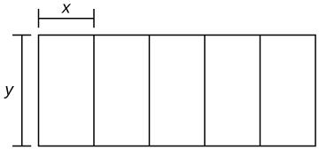

**Question 11 (11 marks)**

The instantaneous velocity (m/min) of a moving object is given by the function as in the diagram below. Assume that on the interval , is given by , and that on every other interval is piecewise linear, as shown.

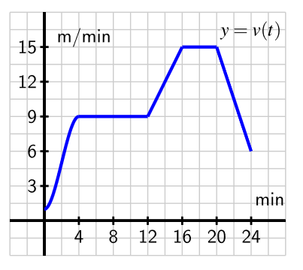

1. Determine the exact distance travelled by the object on the time interval .

(2 marks)

1. Find the object's average velocity on . (3 marks)
2. Find the time the object has the greatest acceleration and justify your answer. (4 marks)
3. Find the total distance travelled during the 24 minutes. (2 marks)

**Question 12 (8 marks)**

(a) A dangerous alga is slowly expanding forming a circular mass threatening to cover one side of a lake. What is the approximate increase in area covered by the algae when the radius expands from to ? Use the small increments formula to find your answer. (4 marks)

(b) A sector has radius *r* cm and angle *θ* radians. Given that its area is fixed, use the small increments formula to find the approximate percentage change in its radius when its angle decreases by

( (4 marks)



**Question 13 (8 marks)**

The new pesticide PET is being developed by CSIRO to inhibit the destruction caused by the Cane Toad The half-lifeof PET is approximately 12 years. Half-life is the time it takes for half of the amount of a substance to decay.

(a) If 100 grams/hectare of PET was sprayed near the Western Australian/ Northern Territory Border in 2018, how long will it take to dissipate to 25 grams/hectare?

(1 mark)

Let represent the amount of PET left whereis in grams/hectare of PET and

where is measured in years. Let time in 2018.

(b) Find the value of (2 marks)

(c) Justify your answer to (a) using the equation. (1 mark)

(d) If the PET reached acceptable levels to be almost harmless to Cane Toads when the 100 grams is reduced to 1 gram, how long would this take to happen?

(2 marks)

(e) How much of the PET will remain on the land in 2050? (2 marks)

**Question 14 (6 marks)**

Suppose that is given by the graph below on the left and



1. Sketch a complete and accurate graph of for on the axes provided on the right. Mark all turning points.



(4 marks)

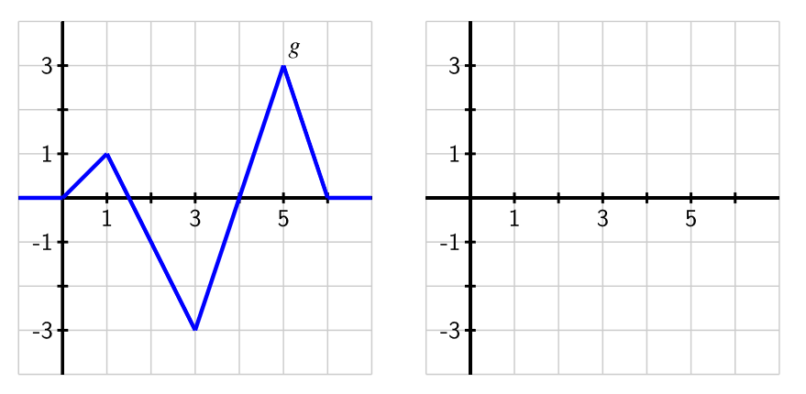

(b How would the graph of compare to , other than , if ?



(2 marks)

**Question 15 (9 marks)**

Let be a discrete random variable with domain only. Suppose the probability function of is given by



with a constant.



1. Determine the probability distribution table and state the value of the constant . (3 marks)



(b) Determine (3 marks)

(c) Determine and the standard deviation of . (3 marks)



**Question 16 (10 marks)**

90 Year 12 students are given five unevenly weighted coins that are more likely to land with the heads face up (heads-up). Each student flips their five coins and makes a note of the number of coins that land heads-up. The group tabulates their results below.

| Number of heads-up coins | 0 | 1 | 2 | 3 | 4 | 5 |
| --- | --- | --- | --- | --- | --- | --- |
| Number of students | 1 | 1 | 3 | 10 | 32 | 43 |

1. Using the results table above, determine
   * 1. The probability that a randomly selected student observes no more than four heads

(1 mark)

* + 1. The mean number of heads observed per student (2 marks)

1. Another student is given five coins to flip. Determine the probability that the student observes no more than 4 heads. You can assume that the number of heads that each student observes is **binomially distributed with the above mean**. (3 marks)
2. Suppose it is known that 70% of all coins would land heads-up and that each student is now given 12 coins. Determine
3. the probability that at least 7 coins will land heads-up for a randomly selected student. (2 marks)
4. the probability that for 15 randomly selected students, exactly 10 students have at least 7 coins that land heads-up. (2 marks)

**Question 17 (11 marks)**

The figure below shows a curve with equation .

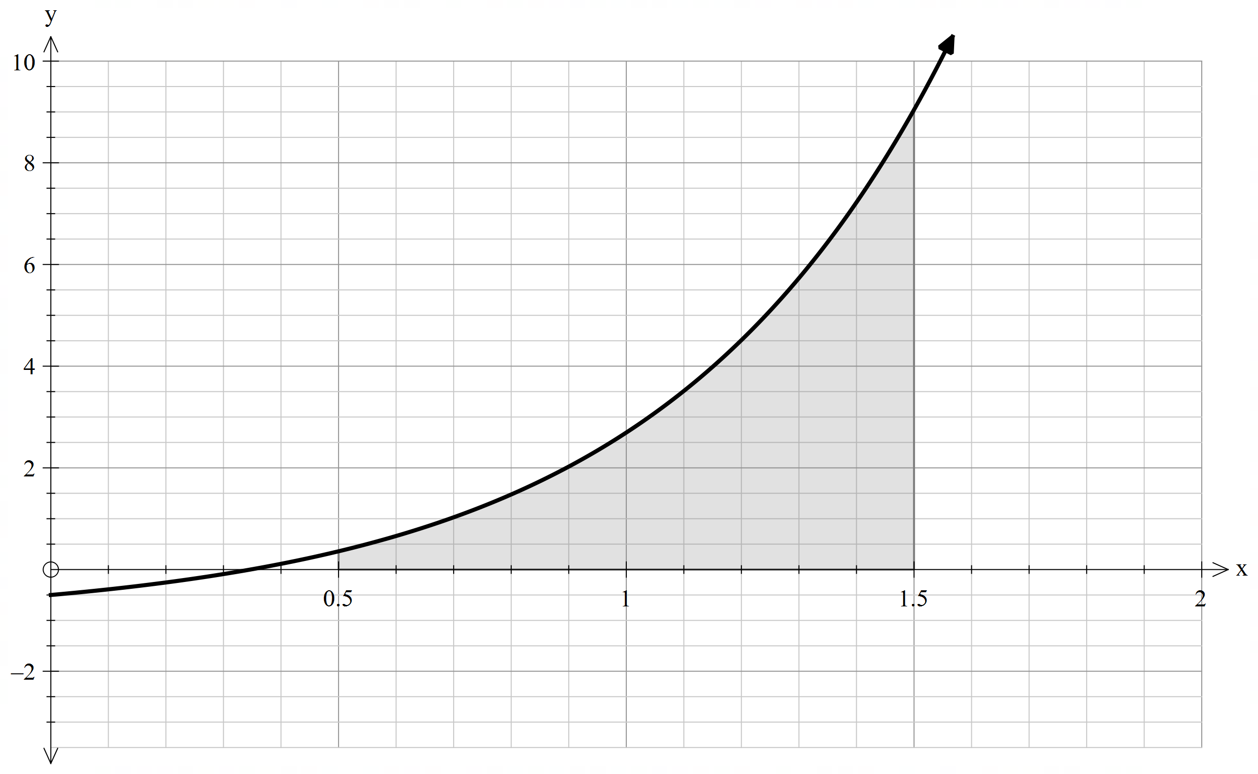

1. Find an underestimate for the area of the shaded region using 4 intervals.

(3 marks)

1. Find an overestimate of the area of the shaded region using 4 intervals.

(3 marks)

1. Using your answers in (a) & (b), determine a better estimate for the shaded region. (2 marks)
2. Is the estimate of the area in part (c) good enough? Discuss two different ways of improving this estimate. (3 marks)

**Question 18 (7 marks)**

Sand is pouring out of a pipe such that the volume (in ) that has poured out after seconds is given by

(where is the time in seconds since pouring began).

The sand forms a conical pile whose radius and volume are related by the equation

a) Determine an expression for in terms of . (2 marks)

b) Determine an expression for in terms of . (2 marks)

c) Write down and hence use the chain rule to determine an expression for in terms of .

(3 marks)

**Question 19 (6 marks)**

A solid concrete wall has a cross section as shown below. The curve is given by the rule with , both are in metres. The wall is uniformly 15 cm thick



and of total length of 10 metres.

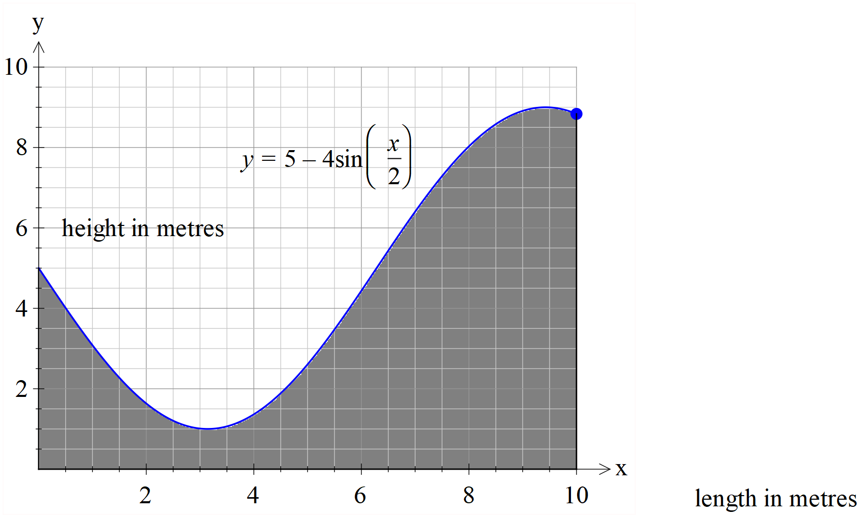

1. Determine the coordinates of the turning points and any inflection points on the curve.

(3 marks)

1. Determine to the nearest cubic centimetre the volume of concrete needed to make the wall. (3 marks)

**Additional working space**

Question number: _______

**Additional working space**

Question number: ________

**Additional working space**

Question number: ________